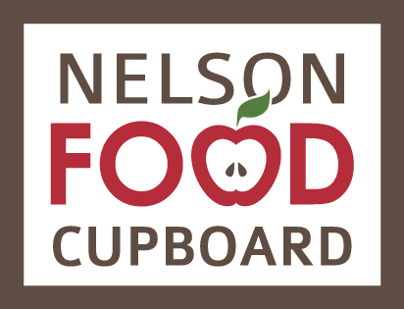
Yes, I want to help our community be more food secure by supporting the work of the Nelson Food Cupboard!

Name: ______________________________________________________________
Address: ____________________________________________________________
Postal Code: _______________
Phone number: _______________________________________________________
Email address: ________________________________________________________

PERENNIAL PARTNER PROGRAM

Monthly giving is a convenient way to support the Nelson Food Cupboard’s ongoing programs throughout the whole year.

I/we authorize the Nelson Food Cupboard Society to withdraw the following each month:
  - $5 buys free range eggs for a family
  - $10 provides a single person with nutritious food
  - $20 strengthens our garden program
  - $30 sustains local food sourcing in our programs
  - $50 teaches a community member how to cook from scratch
  - $100 nourishes a family with a regular supply of fresh produce
  - Other ____________
  - I prefer to make a one-time gift of $________

Signature: ________________________________ Date: __________________________

Important: Please enclose a cheque marked “VOID” to begin the monthly withdrawals or call us to set up a program together with you.
Guarantee: You can change or cancel your monthly donations at any time, so long as you give us 10 days’ notice.

The Nelson Food Cupboard Society is a registered charity
Canada Revenue Agency BN#82876 2344 RR0001. All donations are tax deductible. A tax receipt for your total annual gifts will be sent to you in January.

Please return this form by mail. Stop by Monday 9am – 1pm or Wednesday 1 – 5pm to deliver donations and learn more about our work—or call us at 250 551-0305 to make an appointment. Thank you.

